|  |  |
| --- | --- |
| **EX:NO:4** | **STOCK MAINTAINANCE SYSTEM** |

***SEQUENCE DIAGRAM:***

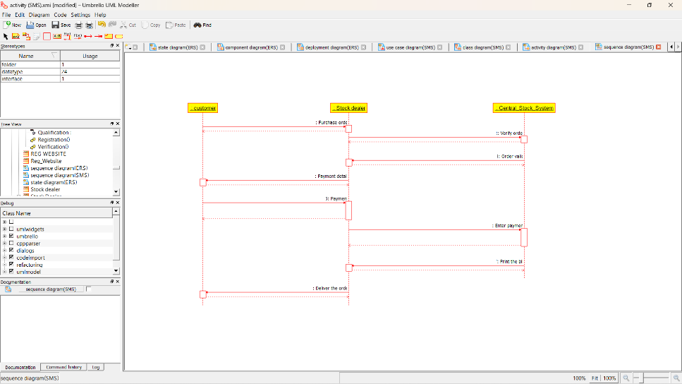

***COLLABORATION DIAGRAM:***

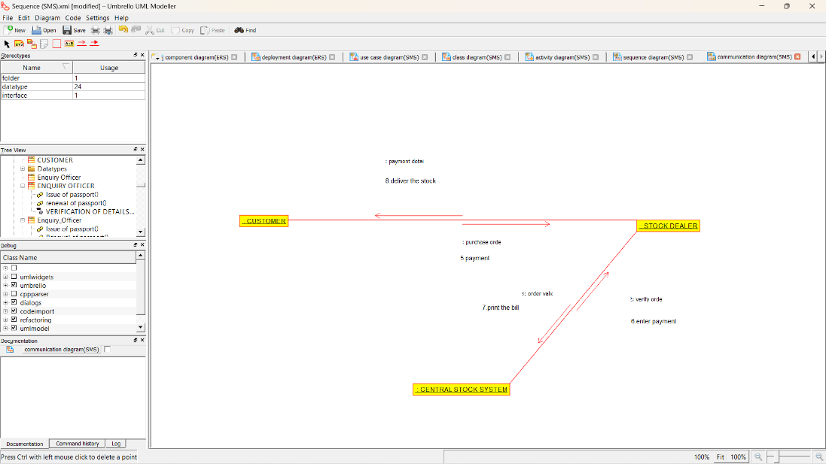

***STATE DIAGRAM:***

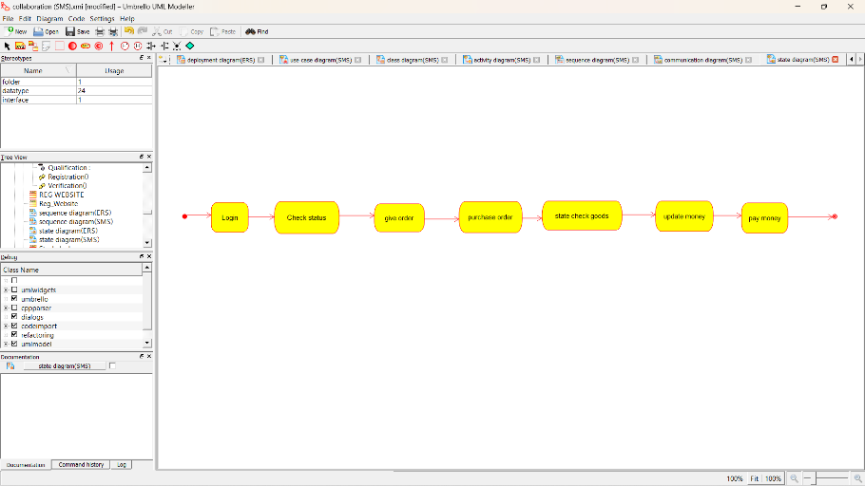

***COMPONENT DIAGRAM:***

